Update Thesis 11-04-2022

Zie code**: https://github.com/DiegoLigtenberg/Workspace-MasterThesis-MSS**

tijdje geleden:

* 4 april jaar geleden dat mijn broertje overleden was; voorbereiding / mind was even niet bij scriptie
* 2 dagen erna ziek geworden (griep), t/m gisteren dagen in bed gelegen
* Goed om weer verder te gaan!

**PREPROCESSING**

* Preprocessing pipeline gemaakt voor Musdb dataset: 150 songs met gevarieerde lengte
* De 150 songs zijn verdeeld in 85 train, 15 validation, 50 test.
* De Preprocessing pipeline ziet er als volgt uit:
  1. Laad de volledige song
  2. Extract 3 second segments
  3. Augment de segments (zit in preprocessing pipeline, maar nog niet opgeslagen)
  4. Pad het signaal (laatste stuk van een song soms 2.1213 seconds -> pad naar 3 seconds door 0 toe te voegen
  5. Extract log spectrogram using stft
  6. Normalize spectrogram based on global statistics (/160)
  7. Save normalized spectrogram as .npy

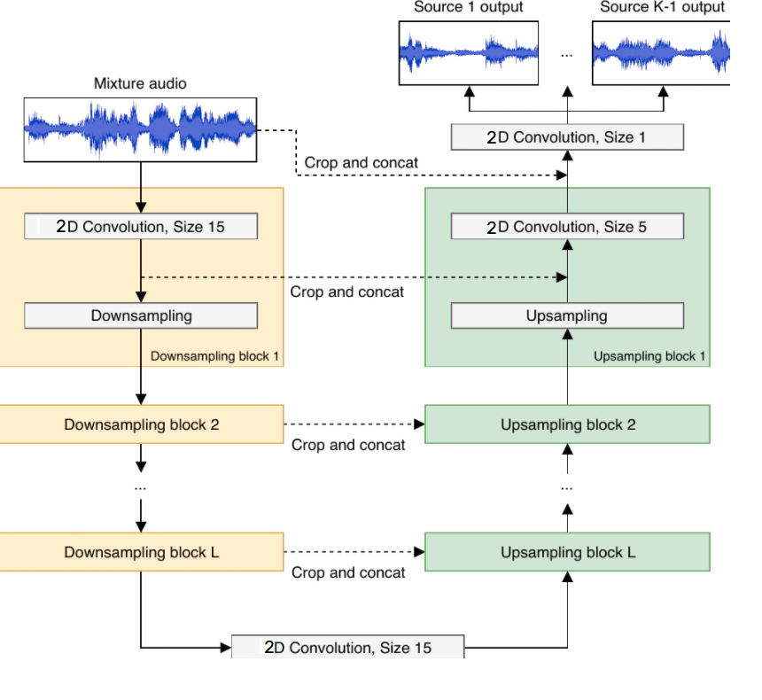

**AUTO ENCODER MODEL**

* Auto encoder gemaakt met skip connections.
* Train dataset bestaat uit 6403 x 2048 x 128 npy files -> te groot om in ram te passen, dus **train on batch** implementation.
* Eerst getrained op 1 sample **mixture -> vocal**, om te kijken of het overfit met close to 0 loss.
  + Dit werkte! mse loss van 2e-5 geeft ‘perfect’ results -> architecture kan werken
* Daarna getest op grotere dataset (veel bugfixes)
  + Niet shuffelen
  + Shuffelen van X en Y waardoor labels mismatchte
  + Geen validation set
  + Verschillende learn rates getest
  + Skip connections werkte niet
* Uiteindelijk stabalized en 1 setting aan main parameters opgeslagen en mee gaan trainen
  + Results:
    - Werkt, maar overfit (voor grootste gedeelte had ik nog geen validation stats om te checken voor overfit) -> pas 2 dagen geleden implemented

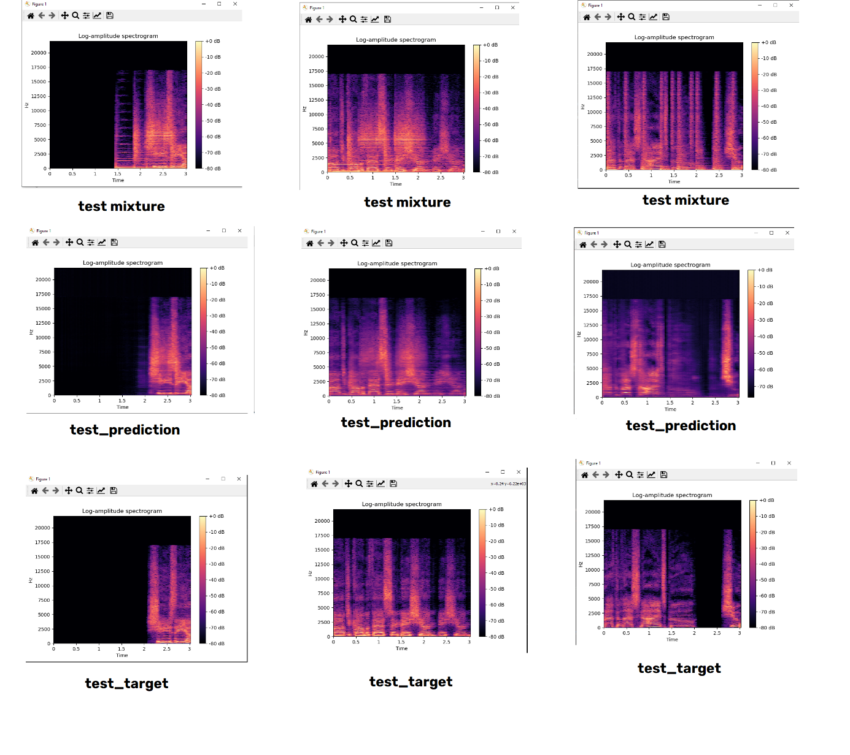

* **GOALS VOOR MIXTURE -> “OTHER” (alleen instruments) om beter te maken (tot 30 april)**
  + **Add regularisation (l2 regularisation + dropout)**
  + **Loss curve voor train/test goed monitoren**
  + **Evt andere visualisations?**

Loss curves

* Validation loss decreased minder snel
* Regularisation techniques implemented -> niet super veel success

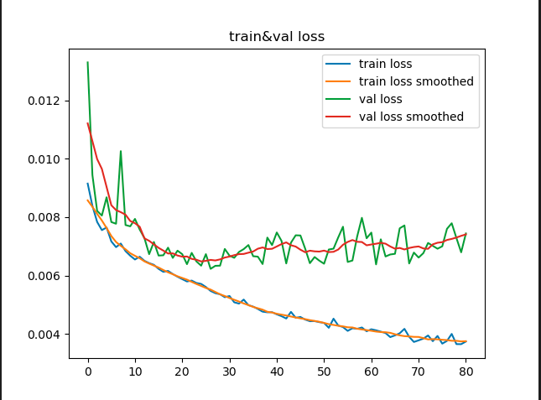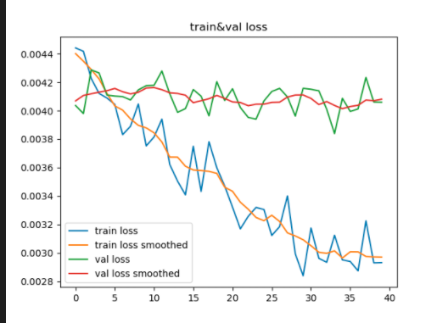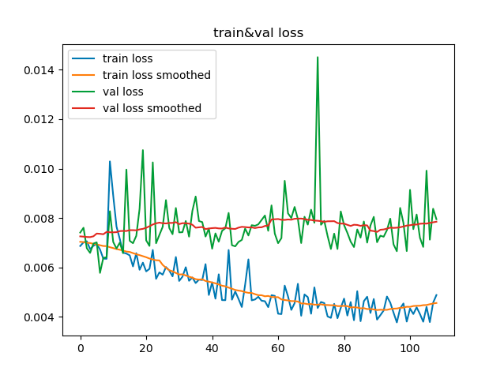

Figure No Batch Normalisation

Figure : Plain model

Figure Dropout + regularisation

Batch normalisation:

* Gekeken naar weights -> erg groot (hoort niet)

Data augmentation

* Polarity inversion
* Reverse signal
* Time stretching
* Pitch shifting

**April 26th**

**Results beginning week:**

* Trained Mixture - > Other (instrumentation without vocal) model
* Experimented with loss functions (but during training)
* Training was mostly done with grid search in mind
  + Trying different loss functions
  + Different learning rates
  + Augmented vs non augmented dataset
  + Model architecture
* 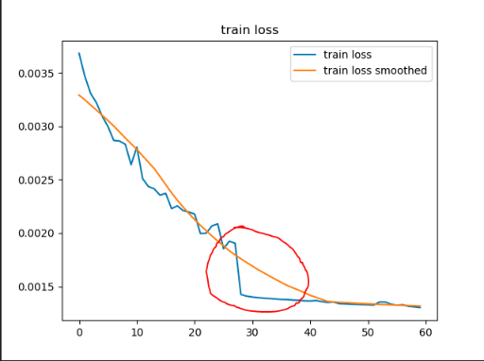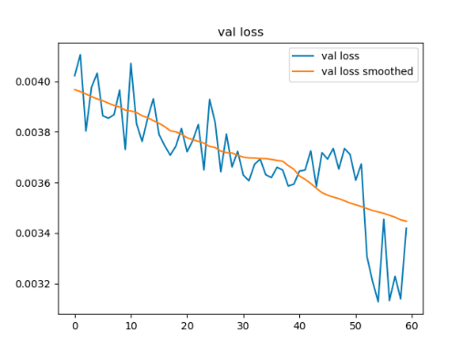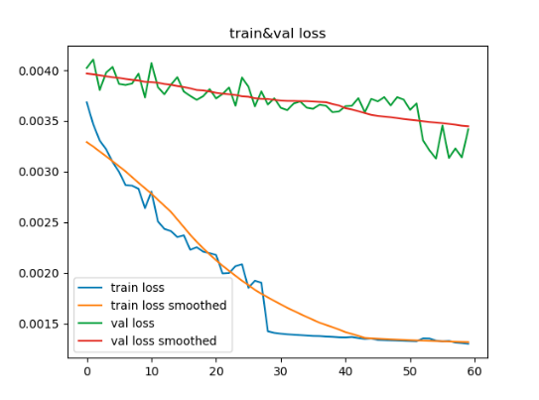Combination of everything gave final model. works ‘okay’ on test set, but does not generalize to other instrumentation. Especially saxphone + vocalinstrumentation got completely blurred.

Train/val train validation

**Mid week:**

* Started looking more into IRMAS dataset
* Cello, clarinet, flute, guitar (elec and acoustic), organ, piano, sax, trumpet, violin, **voice**
* **Voice** is also a recognition instrument -> thus creating any artefacts by removing voice does not make sense!
* **Trained new model that has other + vocal** -> thus removing the drums + bass
* **Because major change** -> looked at proposal + other paper’s doing the same thing and found 3 papers supporting my hypothesis

**3 papers supporting my hypothesis:**

**Singing Voice Separation**

<https://www.researchgate.net/profile/Bidisha-Sharma/publication/335829325_On_the_Importance_of_Audio-Source_Separation_for_Singer_Identification_in_Polyphonic_Music/links/60dd762ca6fdccb745f90fc2/On-the-Importance-of-Audio-Source-Separation-for-Singer-Identification-in-Polyphonic-Music.pdf>

* When converting songs (train + test) to only vocals using WaveUNET -> Singer classification was way easier

**Instrument Classification OLD FASST**

<https://ismir2012.ismir.net/event/papers/559_ISMIR_2012.pdf>

* When using **separated sources on both train + test ->** Detecting instruments is better

They used separate classification algorithm for each separated source -> combined the labels

* Already found slight increase when only test data was source separated with normal train data

**Instrument Classification New** (STILL FASST AND HARMONIC/Percusive from 2014 very old)

https://archives.ismir.net/ismir2018/paper/000145.pdf

* They tested whether using the separation algorithms can be used to increase performance of instrument recognition
* when the **training dataset + test dataset BOTH got separated**, they found best performance

But they used transfer learning -> because source separation is so bad that they had to use weights from previously trained model

Detection of singing foice, or instrument better if you isolate the main source -> in image you would preprocess and potentially remove the background to make network focus on the source of interest!

**End week**

**Created new Dataset -> Vocal + Other (removed drums + bass)**

* tried different architectures and attempt to systematically evaluate different hyperparameters
* Loss function mse 3e-4
* Batch normalisation -> Relu -> (Concatenate) (best order)

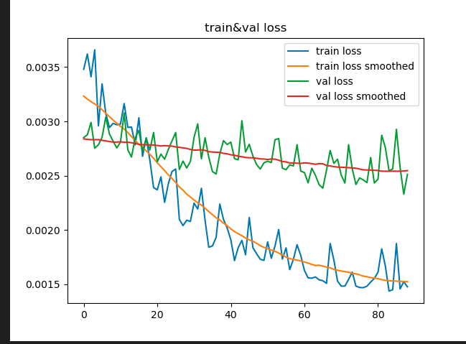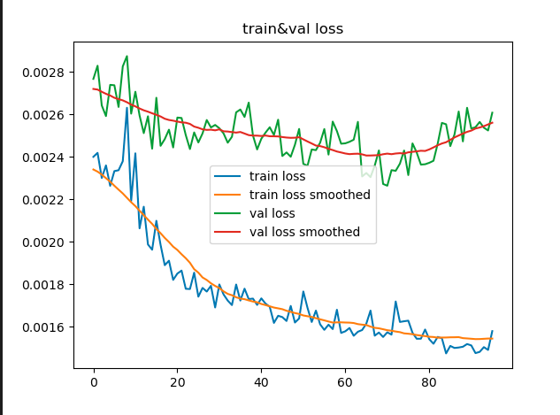

Other + Vocal ReLU -> BN Other + vocal BN -> ReLU

Shortly tested on IRMAS dataset -> at 50 epoch

* Model is less aggressive because only removing bass and drums
* Less artefacts but also sounds bit ‘dof’
* This source separation at least feels useable! Still not perfect, but it does what it has to do
* Compared to previous papers using harmonic/percussion separation -> sounds good!